
Yenepoya (Deemed To Be University)

PROJECT – LOW LEVEL DESIGN
ON
BIG DATA ANALYTICS ON ENERGY DEMAND

BACHELOR OF COMPUTER APPLICATION
DATA SCIENCE, BIG DATA ANALYTICS

Student Name: Devika Babu v
Reg No:23BCDSBA06

Industry Mentor: Mr. Ujjwal kumar |  | Guided by:  Mr. prashantha
Table of Contents
1. Introduction 3
1.1 Purpose and Scope 3
1.2 Project Executive Summary 3
1.3 Intended Audience 3
1.4 System Overview 3
1.5 Constraints 3
1.6 Glossary 4
2. System Design 4
2.1 ETL Pipeline Overview 4
2.2 Process Flow 5
2.3 Information Flow 5
3. Components Design 6
3.1 Dataset Component 6
3.2 ETL Pipeline Component 6
3.3 GroupBy Aggregation — MapReduce Simulation 6
3.4 Storage Component 7
3.5 Visualization Component 7
3.6 Key Design Considerations 7
4. Data Design 8
4.1 Data Model 8
4.2 Data Access Mechanism 8
4.3 Data Retention Policies 9
5. Error Handling and Logging 9
6. Testing Strategy 9
7. Non-Functional Requirements 10
8. Future Enhancements 10
9. References 11

1.Introduction
1.1 Purpose and Scope
This document presents the Low-Level Design (LLD) for the project "Big Data Analytics for Energy Demand Analysis". It demonstrates core Big Data concepts — Extract, Transform, Load (ETL) and MapReduce simulation — using a real-world European energy dataset processed with Python, Pandas, SQLite, and Tableau.

1.2 Project Executive Summary
The project builds a complete ETL pipeline on a historical hourly energy dataset (35,064 rows, 29 columns, 2015–2018). Raw data is extracted, transformed through GroupBy aggregations that simulate MapReduce, loaded into a SQLite database and CSV files, and visualized through Matplotlib charts and an interactive Tableau dashboard with KPI cards.

1.3 Intended Audience
- Academic faculty and students evaluating the BCA final year project.
- The course instructor (Mr. Ujjwal kumar) assessing design and implementation.
- IBM Innovation Center for Education evaluators reviewing Big Data submissions.
- Future developers who may extend or scale this project.

1.4 System Overview
The system is a four-layer local data analytics pipeline with no web interface or authentication. Layer 1 ingests raw CSV data. Layer 2 transforms it through feature engineering and GroupBy aggregations. Layer 3 loads results into SQLite and CSV. Layer 4 visualizes patterns through Matplotlib and Tableau. The entire pipeline runs inside a single Jupyter Notebook (project.ipynb).

1.5 Constraints
- Only the 'total load actual' column is used as the demand indicator. The remaining 28 columns are available for future analysis.
- Processing is done locally using SQLite — no distributed systems like Hadoop or Spark are used. This is intentional to demonstrate Big Data logic on manageable data.
- Dataset is static (2015–2018 only) — no real-time ingestion is implemented.
- The Tableau workbook uses hardcoded local file paths and must be re-linked when moved to another machine.
- 36 null values in 'total load actual' are removed during the cleaning step.

1.6 Glossary
Term | Definition
ETL | Extract, Transform, Load — standard data pipeline process
MapReduce | Big Data programming model; GroupBy in Pandas simulates this
GroupBy | Pandas’ operation that groups rows by a key column and applies an aggregation
SQLite | Lightweight local relational database stored as a single .db file
DataFrame | Two-dimensional labeled data structure in Pandas
Tableau | Data visualization tool for building interactive dashboards
KPI | Key Performance Indicator — summary metric displayed on dashboard
CSV | Comma-Separated Values — flat file format used for data exchange

2.System Design
2.1 ETL Pipeline Overview
The system follows a sequential four-layer ETL architecture. The Ingestion Layer loads and cleans the raw dataset using Pandas. The Transformation Layer extracts time features and applies GroupBy aggregations simulating MapReduce. The Storage Layer persists all aggregated results to SQLite and exports CSV files. The Visualization Layer presents findings through Matplotlib charts and a Tableau dashboard.

Layer | Responsibility | Technology
Ingestion | Load and clean raw dataset | Python, Pandas, pd.read_csv()
Transformation | Feature engineering + GroupBy aggregations | Pandas groupby(), .mean(), .sum()
Storage | Persist to database and flat files | SQLite, .to_sql(), .to_csv()
Visualization | Present insights through charts | Matplotlib, Tableau Desktop

2.2 Process Flow
The diagram below shows the complete end-to-end ETL pipeline from raw data ingestion to project submission.

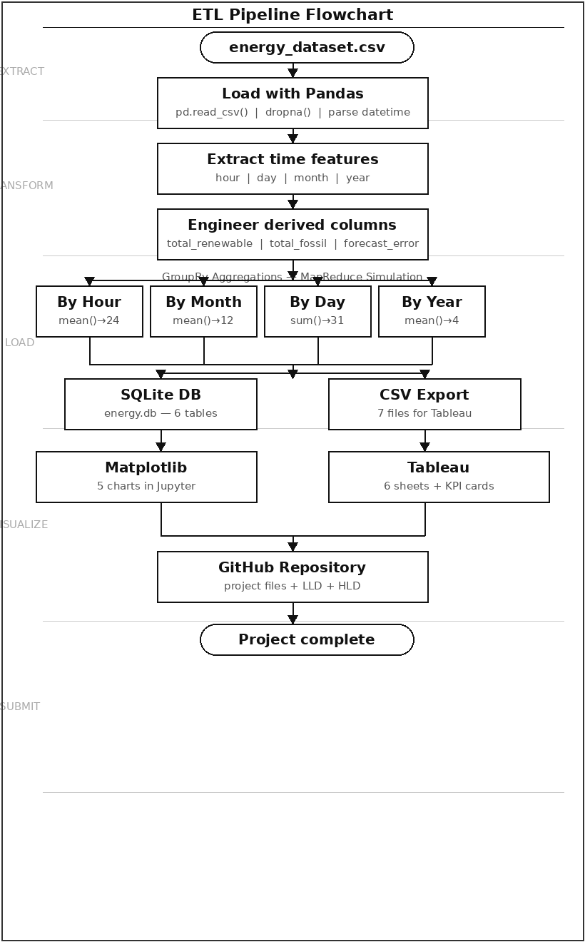
Figure 1: ETL Pipeline Process Flowchart
2.3 Information Flow
From | To | Data | Method
energy_dataset.csv | Pandas DataFrame | 35,064 rows, 29 columns | pd.read_csv()
DataFrame | Cleaned DataFrame | 35,028 rows — nulls removed | df.dropna()
Cleaned DataFrame | Feature DataFrame | + hour, day, month, year columns | .dt accessor
Feature DataFrame | 6 Aggregated Series | Hourly/Monthly/Daily/Yearly/Renewable/Fossil | groupby()
Aggregated Series | SQLite energy.db | 6 tables stored | .to_sql()
Aggregated Series | 7 CSV files | Flat file exports | .to_csv()
CSV files | Tableau Dashboard | 6 sheets + KPI cards | Data source connection

3.Components Design
3.1 Dataset Component
The source file energy_dataset.csv contains 35,064 hourly records from January 2015 to December 2018 across 29 columns. Columns include energy generation by source (solar, wind, nuclear, fossil fuels), load forecasts, actual consumed load, and market prices. The target column used in this project is 'total load actual' which represents real grid-level energy consumption.

3.2 ETL Pipeline Component
The entire ETL pipeline is implemented in project.ipynb. The Extract step loads the CSV, parses the datetime column using pd.to_datetime() with utc=True and errors='coerce', and drops 36 null rows using df.dropna(subset=['time', 'total load actual']). The Transform step creates a clean 'energy' alias column and extracts time features. The Load step writes all results to SQLite and exports CSVs.

3.3 GroupBy Aggregation — MapReduce Simulation
GroupBy aggregations are the core of the Transform step. Each operation maps to the MapReduce paradigm — groupby() is the Map step (partitioning data) and the aggregation function is the Reduce step (collapsing each group to one value).

Aggregation | Code | Output | Reason
Hourly | df.groupby('hour')['energy'].mean() | 24 rows | Average demand per hour — shows daily demand pattern
Monthly | df.groupby('month')['energy'].mean() | 12 rows | Average per month — fair comparison across months
Daily | df.groupby('day')['energy'].sum() | 31 rows | Total per day-of-month — shows day-level load
Yearly | df.groupby('year')['energy'].mean() | 4 rows | Year-wise trend — shows demand growth 2015–2018
Renewable | df.groupby('month')['total_renewable'].mean() | 12 rows | Monthly renewable generation pattern
Fossil | df.groupby('month')['total_fossil'].mean() | 12 rows | Monthly fossil generation for comparison

3.4 Storage Component
All six aggregated DataFrames are written to SQLite using Pandas .to_sql() with if_exists='replace', ensuring clean data on every re-run. The same DataFrames are also exported as CSV files using .to_csv() for use as Tableau data sources. A verification query using pd.read_sql() confirms correct database writes after each load operation.

3.5 Visualization Component
Sheet | Chart Type | X-Axis | Y-Axis | Key Insight
Hourly Energy Demand | Bar chart | Hour (0–23) | Avg Energy (K) | Dual peaks at 11am and 7pm
Monthly Energy Demand | Line chart | Month (1–12) | Avg Energy (K) | July has highest demand
Daily Energy Demand | Area chart | Day (1–31) | Total Energy (M) | Dip at day 31
Yearly Energy Demand | Bar chart | Year (2015–18) | Avg Energy (K) | Steady growth each year
Renewable vs Fossil | Grouped bar | Month (1–12) | Value (K) | Nearly equal generation
Price vs Demand | Scatter plot | Energy (MW) | Price (EUR/MWh) | Positive correlation

3.6 Key Design Considerations
- Mean vs Sum: Hourly, monthly, and yearly use mean() for fair time-based comparison. Daily uses sum() for total load per day number.
- Column aliasing: 'total load actual' is aliased as 'energy' throughout the pipeline for readability.

- Long format CSV: renewable_vs_fossil_long.csv is restructured to long format to enable correct grouped bar chart in Tableau.
- Year filter: df = df[df['year'] >= 2015] removes the single 2014 data point that entered due to UTC timezone conversion.

4.Data Design
4.1 Data Model
The SQLite database energy.db contains six tables, each produced by one GroupBy aggregation in the ETL pipeline. The diagram below shows the schema for all tables.

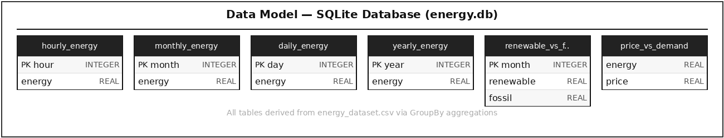
Figure 2: Data Model — SQLite Database Schema (energy.db)

Table | Rows | Key Columns | Aggregation
hourly_energy | 24 | hour (INT), energy (REAL) | mean()
monthly_energy | 12 | month (INT), energy (REAL) | mean()
daily_energy | 31 | day (INT), energy (REAL) | sum()
yearly_energy | 4 | year (INT), energy (REAL) | mean()
renewable_vs_fossil | 12 | month (INT), renewable (REAL), fossil (REAL) | mean()
price_vs_demand | 35,028 | energy (REAL), price (REAL) | raw rows

4.2 Data Access Mechanism
All write operations use Pandas .to_sql() with a sqlite3 connection object and if_exists='replace'. Read operations use pd.read_sql() with standard SQL SELECT statements for verification. CSV flat files serve as the alternative access path for Tableau — no direct SQLite connection from Tableau is used.

4.3 Data Retention Policies
- SQLite tables are fully replaced on each notebook run — no historical versioning within the database.
- Raw dataset energy_dataset.csv is never modified — it is always read-only input.
- All output files are versioned through GitHub commits — each commit represents a project update.

5.Error Handling and Logging
Error handling is built into each stage of the ETL pipeline. During extraction, pd.to_datetime() is called with errors='coerce' which converts malformed timestamps to NaT rather than raising exceptions. These are then caught by df.dropna() before any transformation begins. The SQLite connection uses sqlite3.connect('energy.db') which automatically creates the database if it does not exist. The if_exists='replace' parameter in .to_sql() prevents duplicate data errors on re-runs.

Logging is performed through Jupyter Notebook output at each key step: df.head() confirms correct data loading, df.columns verifies all 29 columns are present, the GroupBy Series is printed before storage to visually verify aggregated values, pd.read_sql() confirms data was written correctly to SQLite, and os.listdir() at the end confirms all seven CSV files and energy.db were created successfully.

6.Testing Strategy
Unit Testing
- Data load test: Verify df.shape returns (35064, 29) after initial read.
- Cleaning test: Verify df['total load actual'].isnull().sum() returns 0 after dropna().
- Aggregation tests: hourly.shape = (24,), monthly.shape = (12,), daily.shape = (31,), yearly.shape = (4,).

Integration Testing
- SQLite write test: pd.read_sql('SELECT COUNT(*) FROM hourly_energy', conn) must return 24.
- CSV export test: os.listdir() must show all 7 CSV files after notebook execution.
- Tableau refresh test: Dashboard must update correctly when CSVs are regenerated.

Tool | Purpose
Jupyter Notebook | Interactive step-by-step verification at each pipeline stage
Pandas .describe() | Descriptive statistics to verify data ranges and detect outliers
pd.read_sql() | Confirm correct data written to SQLite after load step
os.listdir() | Confirm all output files were created successfully
Tableau Data Refresh | Verify dashboard updates when CSV files are regenerated

7.Non-Functional Requirements
Performance Aspects
- Full ETL pipeline executes in under 10 seconds on a standard laptop for 35,028 rows.
- Pandas GroupBy operations are vectorized using NumPy — no Python loops are used for aggregation.
- Tableau dashboard loads within 2 seconds as it reads pre-aggregated CSV files (24, 12, 31, 4 rows) rather than the full raw dataset.
- SQLite writes all 6 tables in under 1 second using .to_sql() batch insert.

Security Aspects
- No user authentication is required — the system is a local analytical pipeline with no web interface.
- The dataset contains no personally identifiable information (PII) — all data is grid-level energy measurements.
- The GitHub repository is public — no sensitive credentials or private data are stored in it.

8. Future Enhancements
8.1 Advanced Data Analysis
- Expand analysis to include generation-by-source columns (solar, wind, nuclear, fossil) to compare supply vs demand patterns.
- Add price analysis using 'price actual' and 'price day ahead' columns to correlate market pricing with demand peaks.
- Implement year-over-year analysis (2015 vs 2016 vs 2017 vs 2018) to detect demand growth trends.

8.2 Big Data Scalability
- Migrate pipeline to Apache Spark (PySpark) to process datasets in the terabyte range using true distributed computing.
- Replace SQLite with a cloud database such as AWS RDS or Google BigQuery for scalable storage.
- Schedule the ETL pipeline using Apache Airflow for automated daily execution.

8.3 Machine Learning
- Build a time-series forecasting model (ARIMA or LSTM) to predict future energy demand based on historical patterns.

- Use the existing forecast columns in the dataset to benchmark model predictions against actual demand.

8.4 Dashboard Enhancements
- Add interactive Tableau filters for year, month range, and energy source type.
- Include KPI summary cards showing peak demand hour, lowest demand month, and year-over-year change.
- Publish Tableau dashboard to Tableau Public for online sharing.

9. References
- Python Software Foundation. Python 3.x Language Reference. https://docs.python.org
- Pandas Development Team. Pandas User Guide and API Reference. https://pandas.pydata.org/docs
- SQLite Consortium. SQLite Documentation. https://www.sqlite.org/docs.html
- Tableau Software Inc. Tableau Desktop Help Documentation. https://help.tableau.com
- Matplotlib Development Team. Matplotlib Documentation. https://matplotlib.org/stable/contents.html
- Hunter, J. D. (2007). Matplotlib: A 2D Graphics Environment. Computing in Science and Engineering, 9(3), 90-95.
- Energy Dataset. Historical Hourly Energy Data (2015-2018). European Network of Transmission System Operators (ENTSO-E). Available via Kaggle.
- IBM Innovation Center for Education. Big Data Analytics Project Guidelines. Yenepoya (Deemed to Be University), 2024.

